top 10 designer saree in surat

Wholesale Designer Sarees in surat
When you point out Indian girls covering, then we are able to guarantee that Sareesis one covering that is worn principally by the women. to stay it a lot of fashionable girls designer sarees is extremely in demand recently. you'd realize multiple outlets around you or on-line looking web site WHO would be providing this lovely covering at the assorted worth vary.distributer WHO obtain Wholesale Sarees and Wholesale
Designer Sarees square measure invariably involved concerning worth. Now, this has been sorted by United States as we tend to being girls sarees manufacturer and girls Sarees distributor it makes United States easier to grant the merchandise at the best worth compared to the other sarees jobber from Republic of India or the hub of Surat.

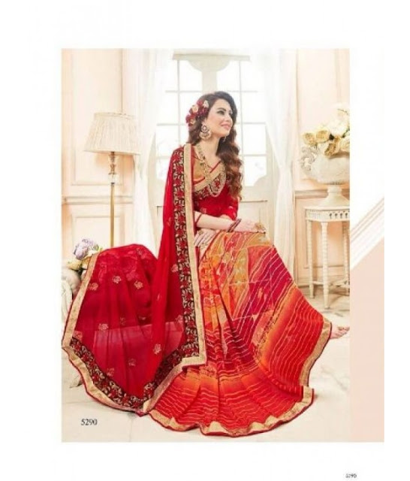

designer wedding sarees
designer wedding sarees is taken into account to be during all|one amongst|one in every of the foremost auspicious moments in a girl's life. they're going to make sure that they're within the better of their apparel. In India, largely Hindus wear sarees on their day in contrast to the western countries as girls wear wedding robes throughout their wedding. Even Catholics wear a marriage robe in Asian country. Designer Wedding sarees ar typically created with designer works and therefore the cloth used for such occasion is Chiffon, Georgette, Silk etc. Most of the Indian weddings like red color sarees because it is taken into account as an honest omen since they're bright in color.

Usually in Asian country once a lady is married, she is going to still wear a frock in her husband's home even supposing she might need ne'er worn a frock throughout her life. this can be the tradition of the Indian culture.

The color red for wedding sarees makes the marriage a special day. Moreover, the wonder of the frock is formed thanks to the beautiful thread work that comes in golden further as silver colours. These colours and styles enhance the entire atmosphere of a marriage and each member of the family attending the marriage can have their focus of the sarees of the bride.

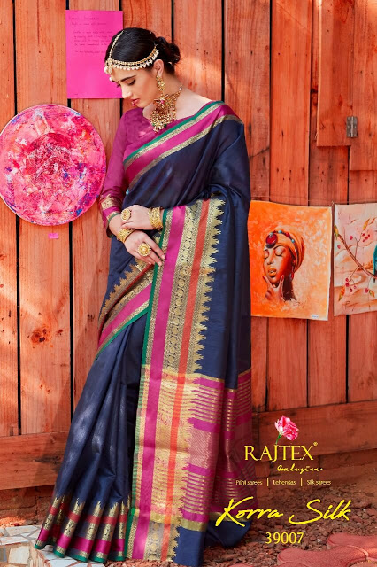

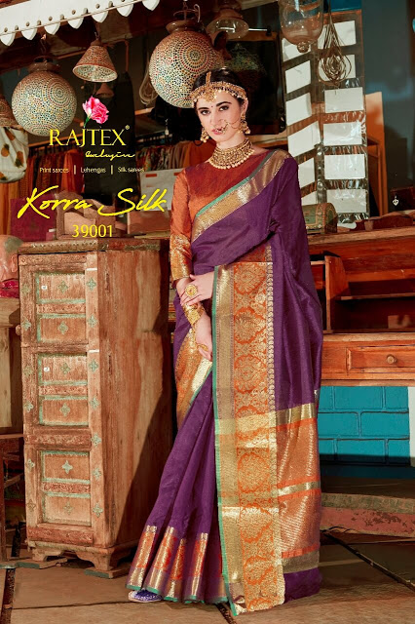

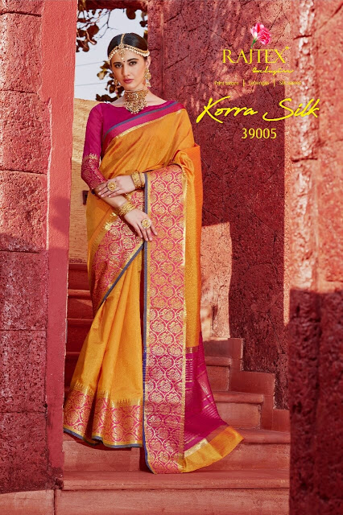

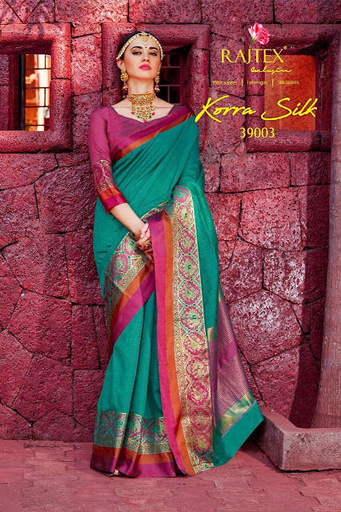

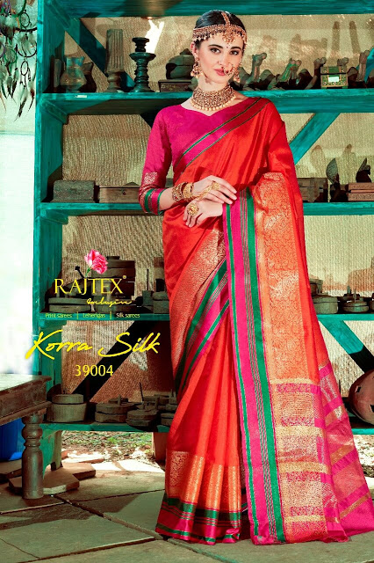

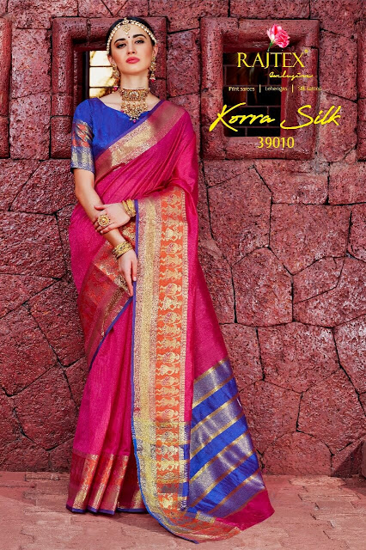

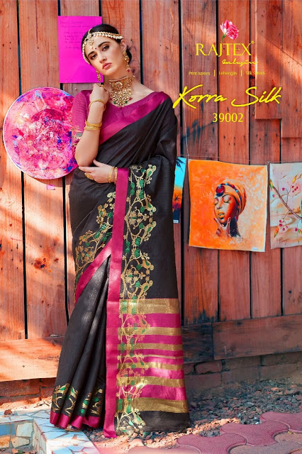

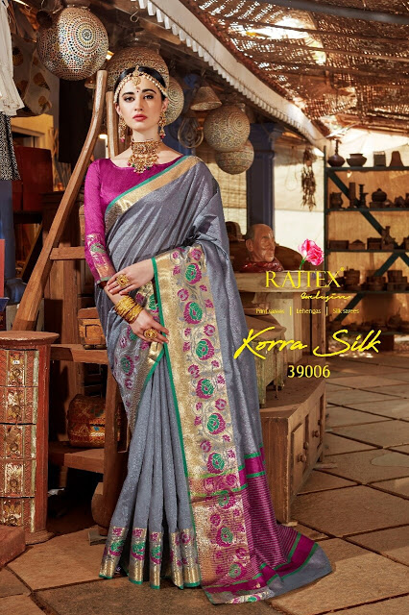

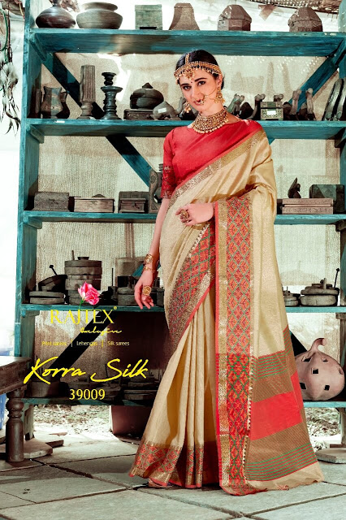

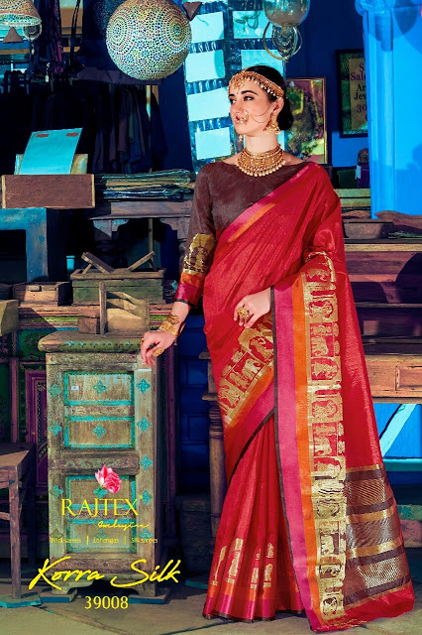

over saree seen by - www.textilebuzz.com

Digital printed Sarees

Get the trendiest of digital printed sarees in our exclusive assortment. It’s a melting-pot of classic and up to date drapes that area unit alive with digital printed, Indian patterns and motifs. boost this a right dose of swish Indian embroideries and you’ve an ideal ethnic outfit to flaunt your far-out aspect. Wear them to an off-the-cuff lunch with of us or drape it to solid a spell at your friend’s wedding. We’ve one for all of your moods and occasions.

Digital Print saree styles

At textilebuzz you get endless ways in which to play with digital prints. we've got totally loveable floral motif sarees - covered digital prints and in an elaborate way designed with exquisite resham, zari, and thread work on border still as pallu. And if you’re an addict of art, choose our digital written abstract work sarees. Dowsed in bright hues and alive with putting shapes and features, they’ve that artsy feel and work well to reveal your creative aspect. With such a beautiful selection, we’re a perfect webstore to shop for your digital printed sarees. Our Indian craftsmen and designers leave no stone right-side-out to deliver that wealthy Indian heritage for your wardrobe. Here, you’ve a specialised team of knowledgeable tailors WHO sew you a wonderfully fitted shirt with oh-so-right size.

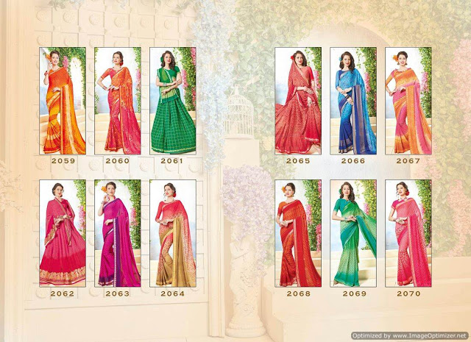

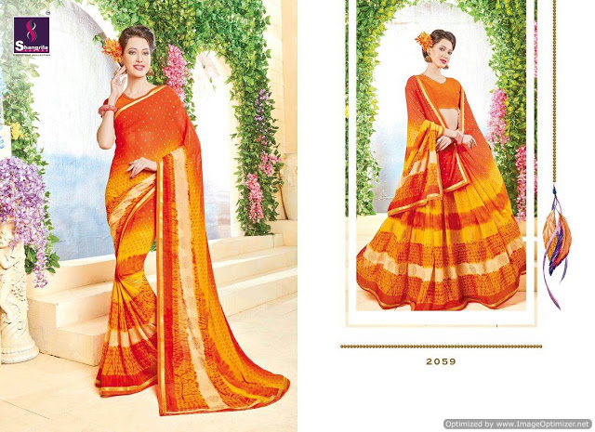

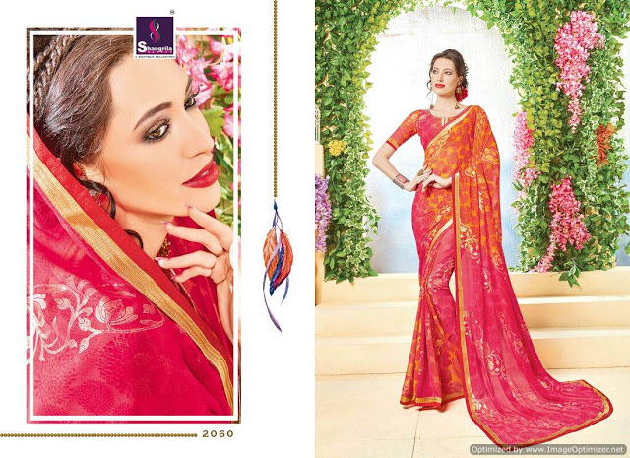

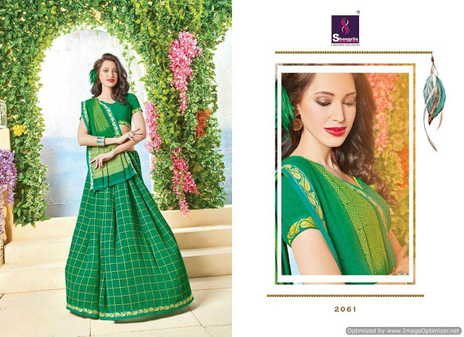

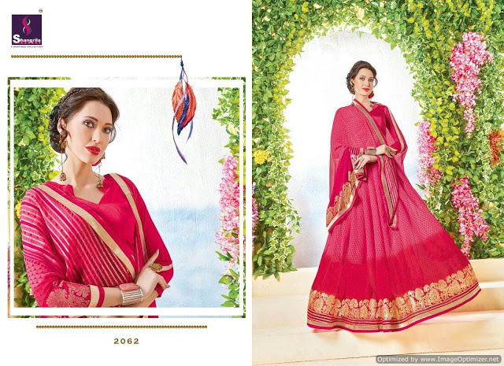

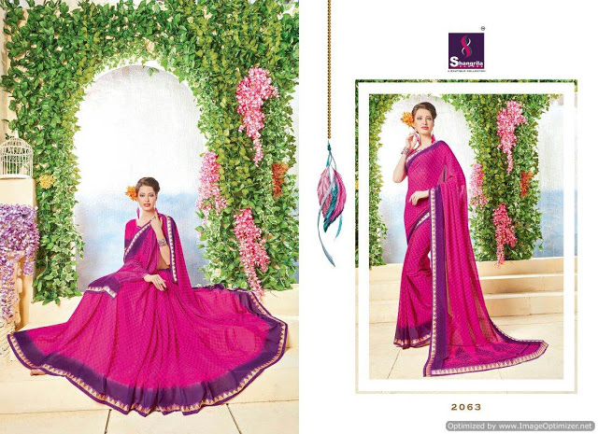

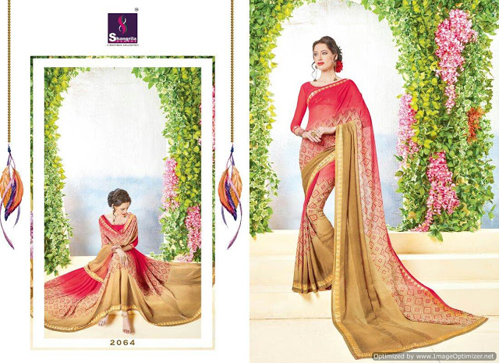

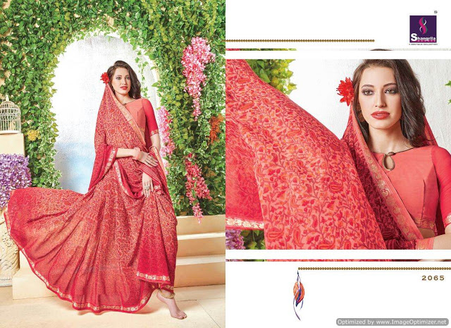

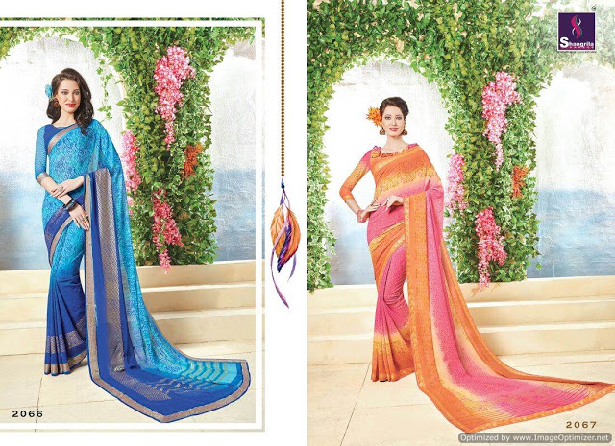

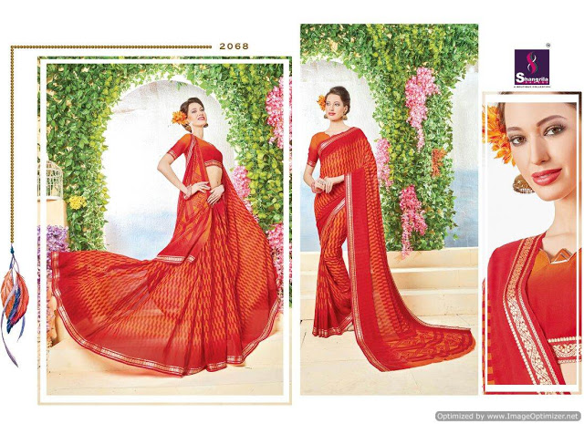

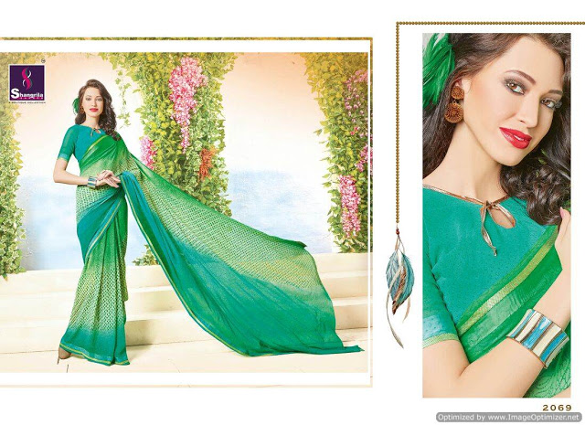

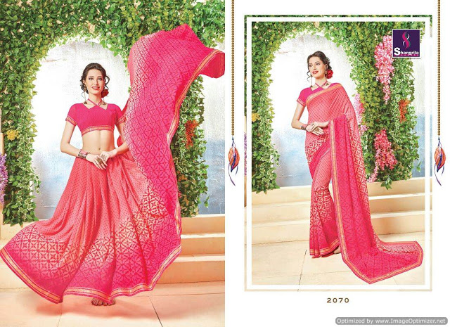

Indian sarees ar world far-famed for its colours, textures and complex embroideries. The made heritage of the frock is beautifying the voluptuous girls of Asian country since times of yore. Indian fashion trends keep dynamical each season and this enables our Indian fashion designers to form and pioneer. Sari, being the foremost ancient apparel of Asian country has undergone a makeover various times. the newest frock creation that has become a rage worldwide could be a designer frock. Pre-stitched sarees and lehenga sarees ar the 2 versions of designer sareesthat are creating appearances on the style runways each season.

wholesale bollywood sarees
Bollywood’s influence on Indian fashion cuts across time and geographics. Everytime the heroines came on screen , collective hearts have fluttered. what number times have you ever desired for the featheredged frock Deepika rocked in Yeh Jawani Hai Deewani? however usually have you ever needed the blue chiffon that caressed Sridevi in Mr India? searching for the attractive Banarasis of Devdas? It may be terribly tough if you don’t apprehend wherever to appear. however the simplest thanks to get the best Bollywood-replica Sarees on-line is to knock at textilebuzz.
Our array of on-line film industry Sarees in up to date materials like internet, Georgette, Crepe, cloth and Lycra is intended to stun. The distinction borders, dramatic pallus and statement blouses area unit the highlights of film industry designer sarees and area unit in-demand at Diwali parties, year galas and musical nights. Explore our vary at textilebuzz to navigate simply, pay simply and obtain simple delivery to international destinations. Welcome to the planet of film industry glitter with textilebuzz.
